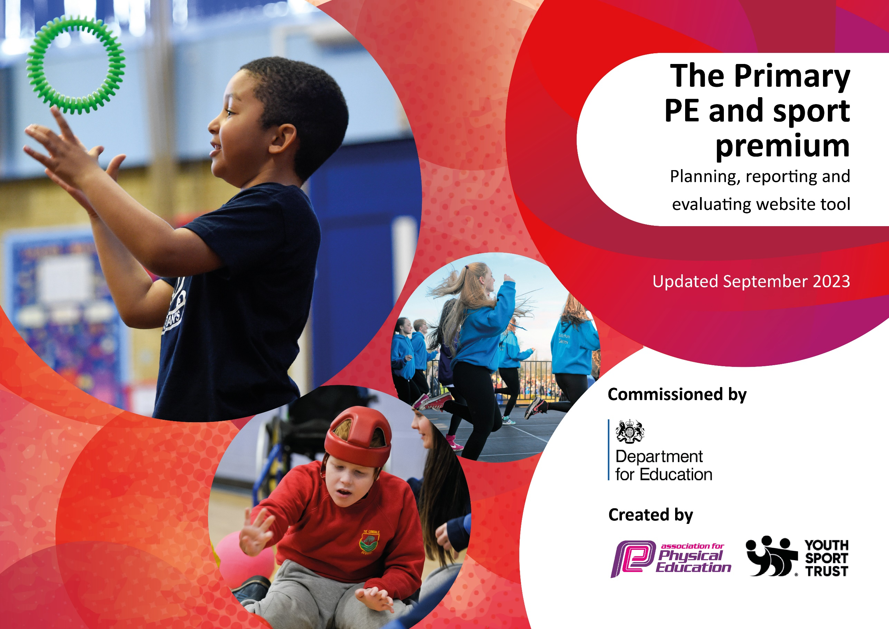

This template can be used for multiple purposes:
by:
- It enables schools to effectively plan their use of the Primary PE and sport premium
- It helps schools to meet the requirements (as set out in guidance) to publish information on their Primary PE and sport premium
- It will be an effective document to support Ofsted inspections enabling schools to evidence progress in Physical Education (PE) and evidence swimming attainment, which forms part of the PE National Curriculum. We would recommend schools consider
the Intent, Implementation and Impact of any spend, as examined within the Education Inspection Framework.

It is important that your grant is used effectively and based on school need.

Schools must use the funding to make additional and sustainable
improvements to the quality of the PE, School Sport and Physical Activity (PESSPA)
they offer. This means that you should use the Primary PE and sport premium to:

- Build capacity and capability within the school to ensure that improvements made now will benefit pupils joining the school in future years
- Develop or add to the PESSPA activities that your school already offers.

The Primary PE and sport premium should not be used to fund capital spend projects; the school’s core budget should fund these. Further detail on capital expenditure can be found in the updated Primary PE and sport premium guidance.

The Primary PE and sport premium guidance, outlines 5 key priorities that funding should be used towards. It is not

necessary that spending has to meet all the key priorities, you should select the priorities that you aim to use any funding towards.

Although completing this template is not a requirement for schools, schools are required to publish details of how they spend this funding. Schools must also outline what the impact this funding has had on pupils’ PE and sport participation and attainment and how any spending will be sustainable in the future. All funding must be spent by 31st July 2024.

The Department for Education has worked closely with the Association for Physical Education (afPE) and the Youth Sport Trust (YST) to develop this template and encourages schools to use it. This template is an effective way of meeting the reporting requirements of the Primary PE and sport premium.
Review of last year’s spend and key achievements (2022/2023)

We recommend you start by reflecting on the impact of current provision and reviewing your previous spend.

Activity/Action | Impact | Comments
- A range of high quality sports clubs offered to all year groups.  - Teachers have had opportunities to observe and team teach with specialist coaches.  - Children have attended sporting events outside of school.  - Bikeablity and balanceability opportunities for some children. | - Well attended sports clubs ensuring children are more physically active.  - Teachers have increased confidence to teach PE.  - Children are excited about taking part in sports events.  - Children who couldn’t ride a bike now can, or have the confidence to have a go. Children know how to ride a bike safely. | - Continue to offer high quality sports clubs next year in line with supporting events outside of school.  - Teachers to team teach with sports coaches to increase confidence further and upskill.  - Continued opportunities for sports events inside and outside of school.  - Continue to plan in bikeability and balanceability as this has proven highly impactful for families.

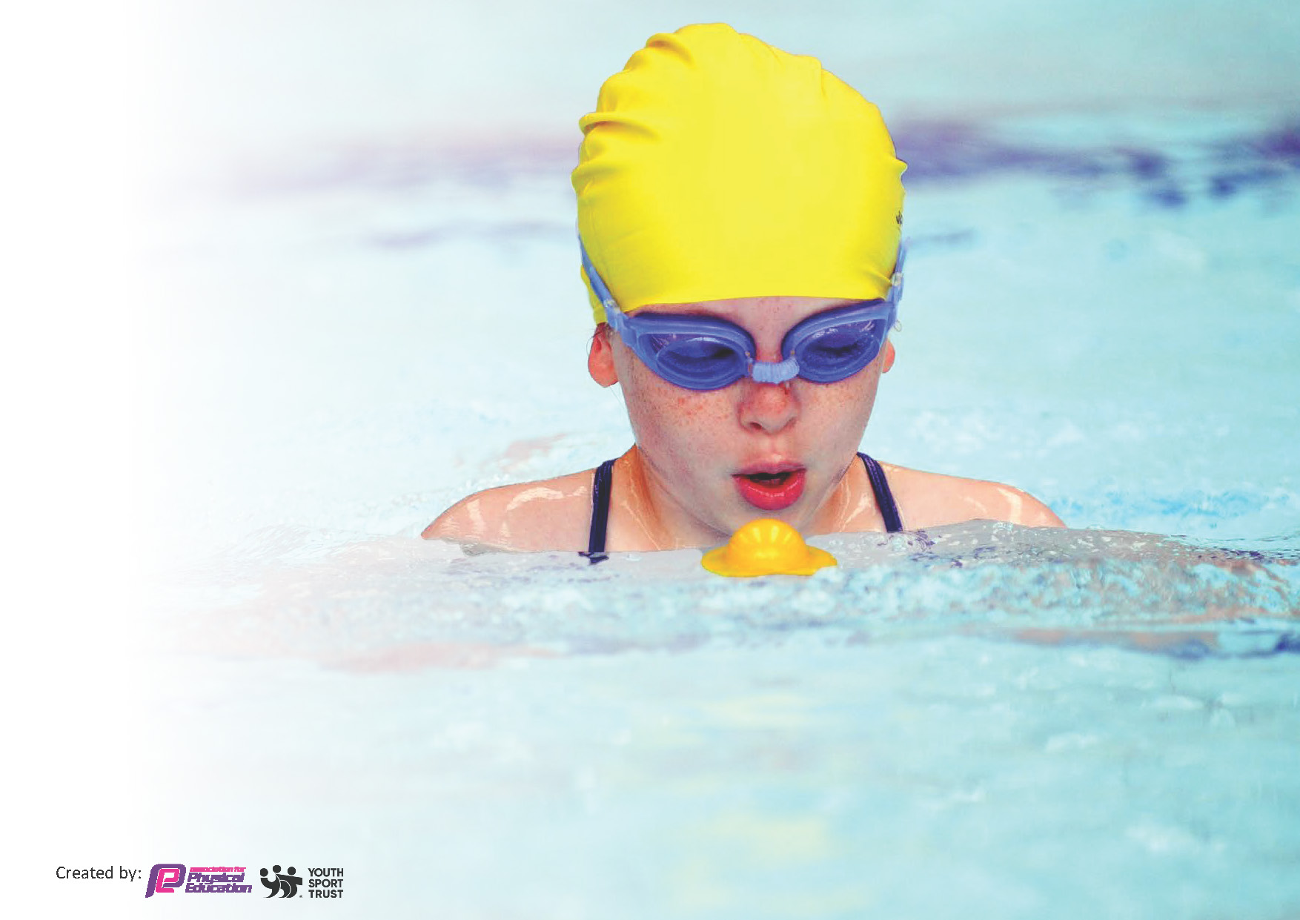
Key priorities and Planning
This planning template will allow schools to accurately plan their spending.

Action – what are you planning to do | Who does this action impact? | Key indicator to meet | Impacts and how sustainability will be achieved? | Cost linked to the action
To make playtimes and lunchtimes more physically engaging.  To have suitable equipment for PE lessons.  To offer high quality sports clubs to all year groups. | Lunchtime supervisors and pupils as they will take part.  Teaching staff and pupils  Coaches, teachers and pupils. | Key indicator 2 -The engagement of all pupils in regular physical activity – the Chief Medical Officer guidelines recommend that all children and young people aged 5 to 18 engage in at least 60 minutes of physical activity per day, of which 30 minutes should be in school.  Key indicator 4: Broader experience of a range of sports and activities offered to all pupils. | More pupils meeting their daily physical activity goal, more pupils encouraged to take part in PE and Sport Activities. | £3890 resources (inc £1800 coordinator time and £368 curriculum materials)  £8460 District sports.

All teachers to have CPD from high quality outside provider.  Children to have opportunities to attend sporting events organised by PSSP.  Teachers to team teach with PSSP coaches.  Classes have opportunities for lessons with PSSP coaches.  Offer clubs to children with existing staff.  PE co-ordinator to have release time to organize PE curriculum, offer support to staff, maintain resources and meet with PSSP staff. | Teachers, PSSP coaches, pupils. | Key Indicator 1: Increased confidence, knowledge, and skills of all staff in teaching PE and sport.  Key indicator 5: Increased participation in competitive sport. | Primary teachers more confident to deliver effective PE supporting pupils to undertake extra activities inside and outside of school, including teaching water safety and swimming and as a result improved % of pupil’s attainment in PE. | £5250 PSSP coaches

Key achievements 2023-2024
This template will be completed at the end of the academic year and will showcase the key achievements schools have made with their Primary PE and sport premium spending.

Activity/Action | Impact | Comments
Buy new equipment for playtimes and lessons.  Use outside provider for clubs  All teachers to attend lessons taught by PSSP.  Children have the opportunity to attend sporting events outside of school and compete against other schools.  PE co-ordinator release time.  Transport to sporting events. | Playtimes are more engaging and active.  Teachers have the correct equipment to teach successful lessons.  All year groups are offered after school sports clubs.  All teachers have had the opportunity to observe and team teach with PSSP coach. Teachers feel more confident in teaching high quality PE lessons.  Children have had the opportunity to attend sports events outside of school and have taken part in well organised competitions.  A range of children, including SEN, have had opportunities to attend sporting events. | These are well attended.  Will continue to provide more CPD opportunities for staff through PSSP.

Swimming Data
Meeting National Curriculum requirements for swimming and water safety.
Priority should always be given to ensuring that pupils can perform safe self-rescue even if they do not fully meet the first two requirements of the National Curriculum programme of study

Question | Stats: | Further context  Relative to local challenges
What percentage of your current Year 6 cohort can swim competently, confidently and proficiently over a distance of at least 25 metres? | 54% | Due to effects post covid many children did not have access to pools to further develop their swimming confidence.
What percentage of your current Year 6 cohort can use a range of strokes effectively [for example, front crawl, backstroke, and breaststroke]? | 47% | See comment above

What percentage of your current Year 6 cohort are able to perform safe self-rescue in different water-based situations? | 77% | Children are able to keep themselves and understand water safety techniques
If your schools swimming data is below national expectation, you can choose to use the Primary PE and sport premium to provide additional top-up sessions for those pupils that did not meet National Curriculum  requirements after the completion of core lessons. Have you done this? | Yes/No | Top up sessions completed in year 5
Have you provided CPD to improve the knowledge and confidence of staff to be able to teach swimming and water safety? | Yes/No | Specialists teachers teach them.

Signed off by:

Head Teacher: | Sharon Burnett
Subject Leader or the individual responsible for the Primary PE and sport premium: | Vickie Bambridge
Governor: | Paul Cotter
Date: | 17.7.24

