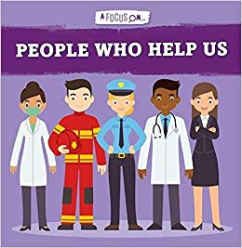

**Physical Development**

* Practice moving in different ways like a superhero e.g.: running, jumping, dancing, hopping, skipping and climbing.
* Use tools safely and effectively to make a vegetable soup.
* Participate in fine motor skill activities to strengthen muscles in hands and develop movements to aid fluency and accuracy with mark making.

**Autumn 2 Key Theme:**

My Heroes

**Communication and Language**

* Ask questions to find out more and to check they understand what has been said to them.
* Listen to and talk about selected non-fiction books to develop a deep familiarity with new knowledge and vocabulary.
* Listen to and talk about stories to build familiarity and understanding.

**Writing**

* Orally plan a sentence before either adult scribes or child attempts to spell words by identifying sounds and writing letters.
* Start to write CVC (consonant, vowel, consonant) words e.g.: ‘bus’, ‘mat’.
* Write correct initial sounds of words

**Understanding the World**

* Explore lives of ‘people who help us’ e.g.: postal worker, doctor, teacher, dentist etc.
* Explore a heroic figure from recent history/local community and tell their story.
* Understand the past through settings, characters and events encountered in books read in class and storytelling.

**Maths**

* **Talk about measure and pattern:**
* Children learn that objects can be compared and ordered by size, mass and capacity.
* Explore simple patterns to develop the understanding of the word and concept.
* Patterns can be both auditory and visual.
* Create own simple patterns.
* **It’s me 1, 2, 3:**
* Explore different representations of 1,2 and 3.
* Recognize the number of objects in a group without needing to count. (Perceptually subitise)

**Reading**

* Reading the following key texts as a class: **People Who Help Us Non-Fiction Series, Supertato** by Sue Hendra and Paul Linnet, **Juniper Jupiter** by Lizzie Stewart.
* Read individual letters by saying the sounds for them.
* Participating in phonics sessions.

**Personal, Social and Emotional Development**

* Express own feelings and consider the feelings of others.
* Identify and moderate their own feelings, encourage children to understand when they feel happy, sad, angry, surprised etc.

**Expressive Arts and Design**

* Develop storylines in their pretend play.
* Create own superhero vegetable using printing and collage materials.
* Create superhero dens and role play narratives based on real life superheroes.