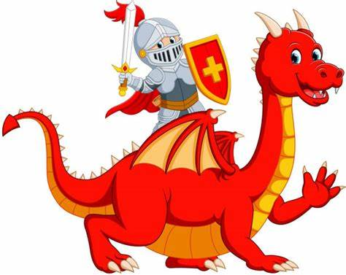

**Maths**

* **Composition of 4 and 5:** Explore and notice the different compositions of 4 and 5.
* **Introducing Zero:** Know that the word ‘zero’ and the numeral 0 represent ‘nothing there’.
* **Compare numbers to 5:** Make comparisons between groups of 0-5 objects.
* **Compare length, weight, and capacity:** Compare mass and capacity using appropriate mathematical vocabulary.
* **Recognise 6, 7 and 8 by counting or subitising**
* **Making Pairs:** Understand that a pair is 2 and notice when some quantities have an odd one out
* **Combining 2 groups to find out how many altogether.**

**Expressive Arts and Design**

* Sing and perform nursery rhymes
* Create dragon pictures and create texture by using different techniques e.g.: textured paint.
* Develop storylines in their pretend play e.g.: dragon’s kitchen themed role play.

**Reading**

* Reading the following key texts as a class: **Selection of non-fiction texts** about castles, **The Very Last Castle** by Travis Jonker and **George and the Dragon** by Christopher Wormell.
* Know the meaning of new vocabulary e.g.: tower, turret, stone, bricks, drawbridge, portcullis, moat.
* Retell a story using a story map.
* Make predictions about what will happen next.

**Personal, Social and Emotional Development**

* Discuss what it means to be a good friend
* Listen to stories about brave and not so brave knights, identify what bring brave means.
* Build castles cooperatively with peers.
* Work with a friend to plan out a challenge
* Develop resilience and perseverance in the face of challenge.

**Spring 1 Key Theme:**

Castles, Knights and Dragons

**Writing**

* Innovate a story using a story map (change elements to make it your own).
* Write CVC/CCVC/CVCC words using sounds taught in phonics.
* Write a list.
* Say simple sentences out loud and write these using phonetically plausible sounds.

**Communication and Language**

* Make simple predictions about what will happen next.
* Retell a story.
* Listen carefully and learn rhymes, poems and songs.

**Understanding the World**

* Compare photographs from present day and the past.
* Learn about modern day and historic kings and queens.
* Compare and contrast characters from stories, including figures from the past.
* Recognise that people have different beliefs and celebrate special times in different ways e.g.: Chinese New Year.

**Physical Development**

* Use large outdoor construction materials to build own castle.
* Use apparatus in different ways to travel over, under or around.
* Create models from playdough/salt dough.
  + Take part in a variety of fine motor activities.